Data Structure (2)

NAMES: -Ahmed Morsy 4448 --Merna Zakaria 4106

Sorting techniques

**Sorting Techniques:**

**NLogn Sorting:**

Heap Sort:

Building Heap:

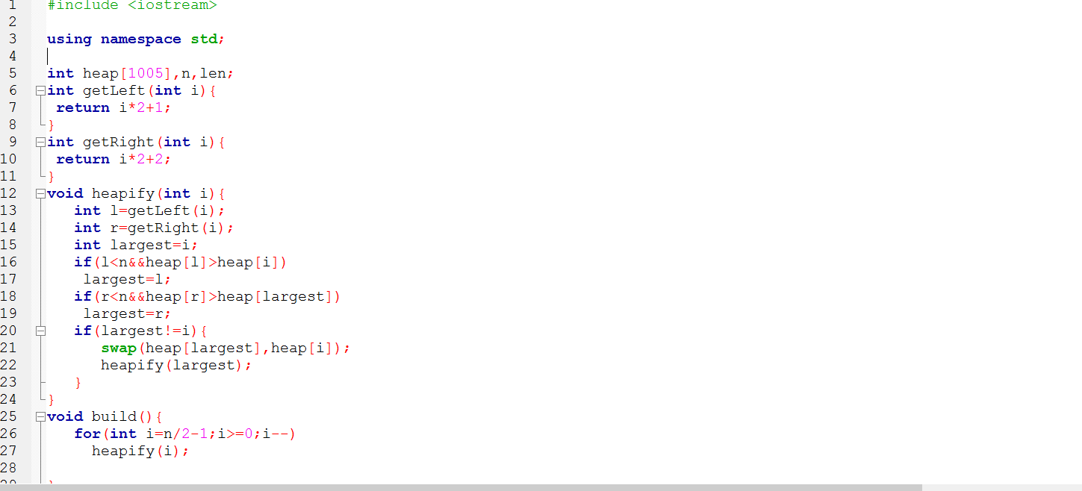

Heap: A Binary Heap is a Complete Binary Tree where items are stored in a special order such that value in a parent node is greater than the values in its two children nodes. The former is called as max heap and the latter is called min heap. The heap can be represented by array.

Heap Sort:

. Build a max heap from the input data.

. At this point, the largest item is stored at the root of the heap. Replace it with the last item of the heap followed by reducing the size of heap by 1. Finally, heapify the root of tree and so on until we finish the array.

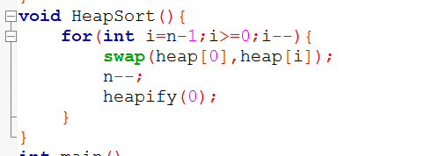

.Complexity nLogn.

QuickSort:

It utilizes a divide-and-conquer strategy to quickly sort data items by dividing a large array into two smaller arrays.

Its complexity depends on choosing the pivot.

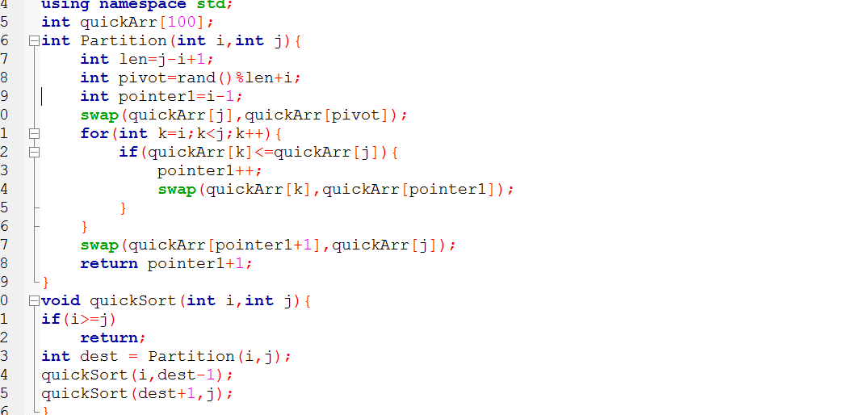

Running:



**Merge Sort:**

A sort algorithm that splits the items to be sorted into two groups, recursively sorts each group, and merges them into a final, sorted sequence. Run time is O(n log n).

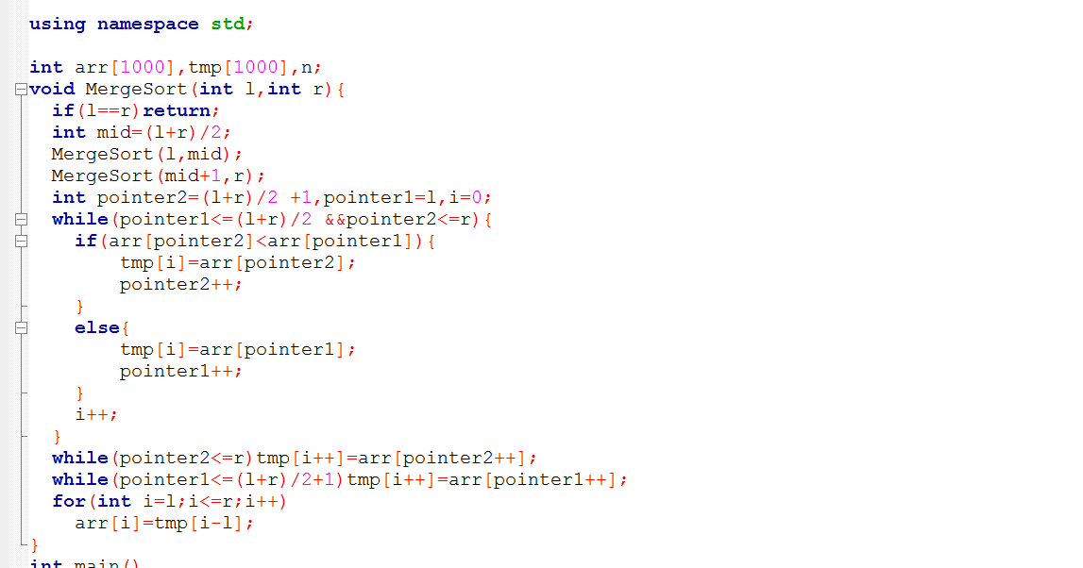

**Sorting Complexity N Squared:**

BUBBLE SORT & Insertion Sort:

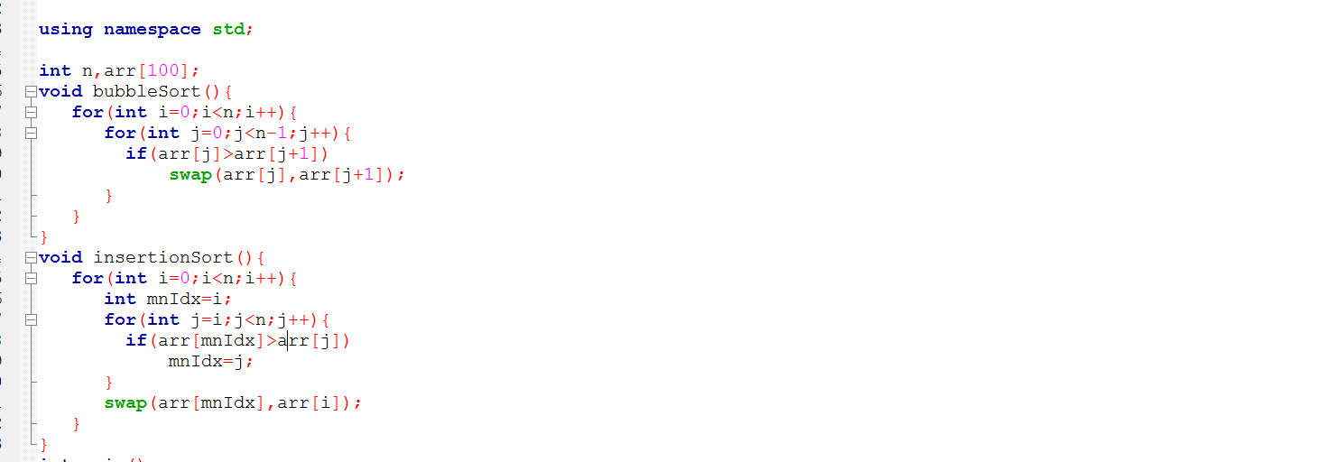

**COMPARSION BUBBLE VS QUICK:**

Code of EXECUTION TIME:

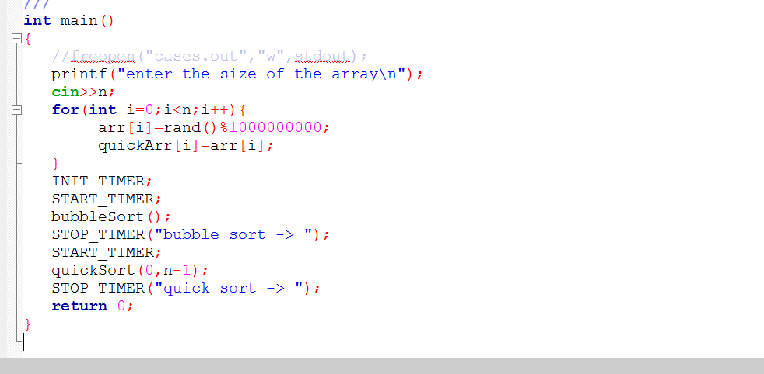

Running Code on different value of n ScreenShots:

N=100:

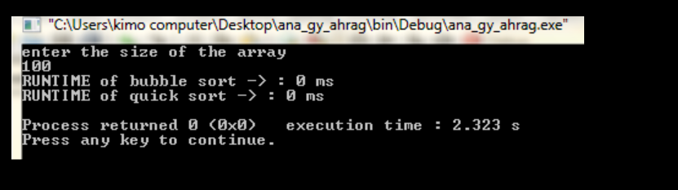

N=10000:

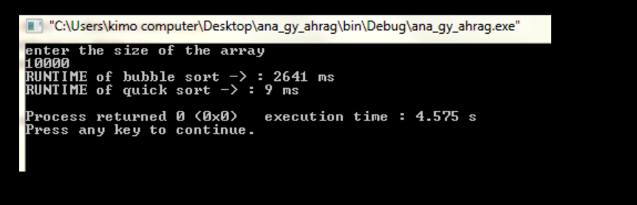

Plotting Bubble vs quick:

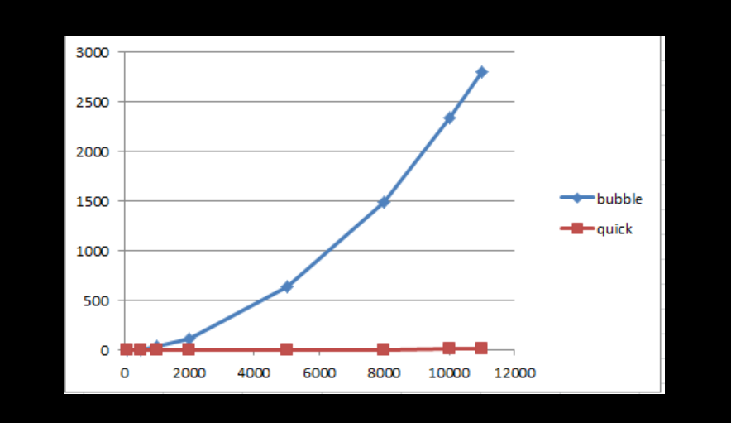

Bubble Sort:

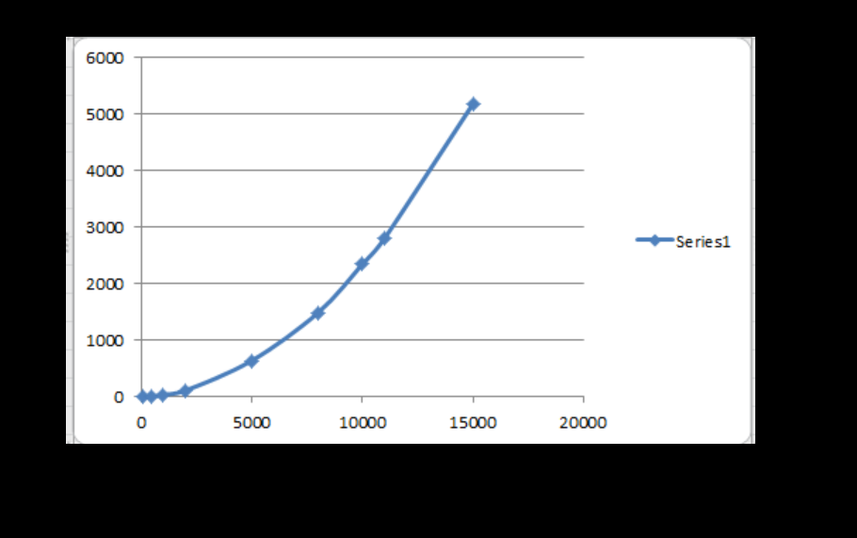

Quick Sort:

